EXPERIMENT NO: 3

Name: Vijithra Nair
Class: TE Comps B
Roll No: 41

AIM: Design and implement home page using CSS3 and HTML5 for online pharmacy store.
PROGRAM:
Your cart.html:
<!DOCTYPE html>
<html>
<head>
<meta charset="utf-8">
<title>
Your cart
</title>
<style>
*{
margin: 0;
padding: 0px;
}
li{
list-style: none;
}
</style>

<link rel="stylesheet" type="text/css" href="style.css">
</head>

<body>
<div class="header">
<div class="header-logo"><img src ="vitacare.jpeg" width="30%" height="10%"></div>
<div class="header-list">
<ul>
<li><a href="#">HOME</a></li>
<li><a href="#">PURCHASES</a></li>
<li><a href="#">YOUR CART</a></li>
<li><a href="#">PAYMENTS</a></li>
<li><a href="#">LOGIN</a></li>
</ul>
</div>

</div>
<div class="main">
<br>
<div class="heading" >
<center><img src="carrt.png" width="7%" height="7%">&nbsp;&nbsp;&nbsp;<label><b><u>YOUR CART</u></b></label></center>
</div>
<a href="#">Previous Page</a>
&nbsp;&nbsp;&nbsp;&nbsp;&nbsp;&nbsp;&nbsp;&nbsp;&nbsp;&nbsp;&nbsp;&nbsp;&nbsp;&nbsp;
<a href="#"> Next Page</a>
<br>
<br>

<div class="selected">
<p align="right">
<br>
<b><u><center>DEALS OF THE DAY!!</center></u></font></b>
</p>
&nbsp;&nbsp;&nbsp;
<img src="babycare.jpg" width="23%" height="16%">
&nbsp;&nbsp;&nbsp;&nbsp;&nbsp;&nbsp;&nbsp;&nbsp;&nbsp;&nbsp;&nbsp;&nbsp;&nbsp;&nbsp;&nbsp;&nbsp;&nbsp;
<img src="sale1.jpg" width="23%" height="16%">
&nbsp;&nbsp;&nbsp;&nbsp;&nbsp;&nbsp;&nbsp;&nbsp;&nbsp;&nbsp;&nbsp;&nbsp;&nbsp;&nbsp;&nbsp;&nbsp;&nbsp;
<img src="sale2.png" width="10%" height="5%">
&nbsp;&nbsp;&nbsp;&nbsp;&nbsp;&nbsp;&nbsp;&nbsp;&nbsp;&nbsp;&nbsp;&nbsp;&nbsp;&nbsp;
<img src="sale3.png" width="15%" height="10%">

<br>
<br>
<p class="sale" align="center">
<b>& MANY MORE UPTO OF 40% MEGA SALES!!! COME COLLECT NOW!!</b></p>
<br>
</div>

<br>
<br>
<fieldset>

<div class="items">
<br>
<label><h2><b><center>Items Purchased</font> </b></h2></label></center>
<br>
<br>
<br>
<ul>

<li><label><b> Rose's Lavender oil<br><br>Rs 400</b></label></li>
<br>
<img src="lavender oil.jpg">
<br>
<p style="color:#581845;text-align:left;font-size:18px;">Add to bath water to relax & refresh your body. Add 2 to 3 drops of Essential oil to any Carrier oil and apply on hair & skin for best results. Packed with powerful therapeutic properties, Lavender oil works magically in assisting skin for a soft, supple and refreshed look. Uplift your mood by using Lavender oil in a diffuser.</p>
<br>
<label>no. of items:</label><input type="number" name="items">

<br>
<br>

<li><label><b>Olena Vitamin C booster<br><br>Rs 150</b></label></li>
<br>
<img src="vitamin c.png" width="15%" height="10%">
<p style="color:#581845;text-align:left;font-size:18px;">
<br>
Finding it difficult to get your Vitamin C? Formulated to boost your immunity with clinically proven ingredients, our Immunity effervescents are high in Vitamin C and bioflavonoids to help fight common colds, allergies and sicknesses. If you're not a fan of swallowing tablets, you will love this delicious orange juice fizz!
<ul>
<li> Amla 1000mg Vitamin C + 100mg bioflavonoid per tablet</li>
<li> Prevents and alleviates common colds, flu and sickness</li>
<li> Provides essential nutrients for energy and immune support</li>
<li> Fights fatigue and boosts energy levels</li>
<li> Dissolves fast and refreshing orange taste</li>
</p>
</ul>

<br>
<label>no. of items:</label><input type="number" name="items">

<br>
<br>

<li><label><b>Crocin<br><br>Rs 500/box</b></label></li>
<br>

<img src="crocin.jpg">
<br>
<p style="color:#581845;text-align:left;font-size:18px;">It starts releasing its medicine in as little as 5 minutes. It gets absorbed 25% faster than standard paracetamol.</p>
<br>
<label>no. of items:</label><input type="number" name="items">

<br>
<br>

<li><label><b>Lemon & Spearmint Moisturizing hand sanitizer spray<br><br>Rs 200</b></label></li>
<br>
<br>
<img src="sanitizer.jpg" width="15%" height="15%">
<br>
<p style="color:#581845;text-align:left;font-size:18px;">RAS Moisturising hand sanitiser spray made with Moisturising ingredients such as aloe gel & Vegetable glycerin offers rinse free protection on the go. With an easy to use spray option it can also be used to sanitise phones, and small surfaces such as handles and doors when travelling. The refreshing spearmint essential oil gives an energising aroma aroma and lemon acts as a natural antibacterial.</p>
<br>
<label>no. of items:</label><input type="number" name="items">
</ul>
<br>

</div>

</fieldset>
<br>
<br>
<h2><center>Payment Details</center></h2>
<br>
<fieldset>
<br>
<label>Payment type</label>
&nbsp;&nbsp;&nbsp;&nbsp;&nbsp;&nbsp;&nbsp;&nbsp;&nbsp;&nbsp;&nbsp;&nbsp;&nbsp;&nbsp;&nbsp;&nbsp;&nbsp;&nbsp;&nbsp;&nbsp;&nbsp;&nbsp;
<input type="radio" name="pay1" value="plan"required><label>Debit/Credit card</label>
<br>
&nbsp;&nbsp;&nbsp;&nbsp;&nbsp;&nbsp;&nbsp;&nbsp;&nbsp;&nbsp;&nbsp;&nbsp;&nbsp;&nbsp;&nbsp;&nbsp;&nbsp;&nbsp;&nbsp;&nbsp;&nbsp;&nbsp;&nbsp;&nbsp;&nbsp;&nbsp;&nbsp;&nbsp;&nbsp;&nbsp;&nbsp;&nbsp;&nbsp;&nbsp;&nbsp;&nbsp;&nbsp;&nbsp;&nbsp;&nbsp;&nbsp;&nbsp;&nbsp;&nbsp;&nbsp;
<input type="radio" name="pay1" value="plan"required><label>GPay/Paytm</label>
<br>
&nbsp;&nbsp;&nbsp;&nbsp;&nbsp;&nbsp;&nbsp;&nbsp;&nbsp;&nbsp;&nbsp;&nbsp;&nbsp;&nbsp;&nbsp;&nbsp;&nbsp;&nbsp;&nbsp;&nbsp;&nbsp;&nbsp;&nbsp;&nbsp;&nbsp;&nbsp;&nbsp;&nbsp;&nbsp;&nbsp;&nbsp;&nbsp;&nbsp;&nbsp;&nbsp;&nbsp;&nbsp;&nbsp;&nbsp;&nbsp;&nbsp;&nbsp;&nbsp;&nbsp;&nbsp;
<input type="radio" name="pay1" value="plan"required><label>Cash on Delivery</label>
<br>
<br>
<center><input type="reset" value="Reset" width="8%" height="3%" alt="Reset"></center>
<br>
<center><input type="submit" value="Submit" width="8%" height="3%" alt="Submit"></center>
<br>
</fieldset>
</div>

<br>

<h3 class="section-title">Contact us</h3>

<br>
<p>Email (Required)</p>
<input>
<p>Message (Required)</p>
<textarea></textarea>
<p> * Required fields must be filled.</p>
<input class="contact-submit" type="submit" value="Send">

</div>

<div class="footer">
<div class="footer-logo"><u>VITACARE</u><br><p> Passion for excellence.Compassion for people</p><br><img src ="vitacare.jpeg" width="30%" height="10%"> </div>
<div class="footer-list">
<ul>
<li>About</li>
<li>Contact us</li>

<li>FAQS</li>
<li>New Registration</li>
<li>Feedback</li>
</ul>

</div>

</div>

</body>
</html>
Style.css

.header{
background-color: #DBB5F7;
height: 100px;

}
.header-logo{
float: left;
padding: 10px;

}
.header-list li a{

padding: 33px 37px;
float: left;
text-decoration: none;
color: black;
margin-top: 25px;
padding: 5px 30px;
}

.header-list a:hover{
background-color: white;
color: black;
}

.main{
background-color: #E1F9CF;

}
.heading{
font-size: 30px;
}
.selected{
border: 7px solid gray;
background-color: #B5EAD7;
font-family: "Avenir Next";
color: #B05F3C;
font-size: 25px;
}
.sale{
font-family: serif;
color: #800080;
font-size: 20px;

}
.items{
background-color: #FFDAC1;
height: 1910px;
}
h2{
font-family:"Times new roman";
font-size: 30px;

}

.contact-form{
padding:30px;
}
input,textarea {
width:100px;
margin-top:5px;
margin-bottom:5px;
padding:20px;
font-size:12px;
border: 1px solid #dee7ec;
}
.contact-submit {
background-color:#dee7ec;
color:#889eab;
}
.footer{
background-color: #4E6B8A;
height: 130px;
padding: 40px;
}
.footer-logo{
color: white;
font-size:25px;
float: left;

}
.footer-list{

color: white;
font-size: 20px;
float: right;

}
.footer list li{
padding: 25px;
}

OUTPUT:
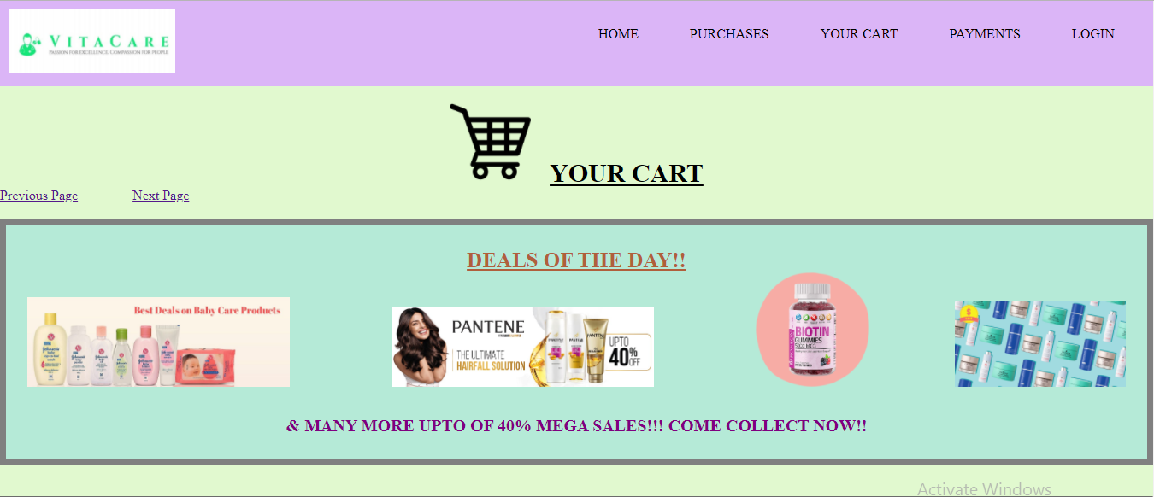
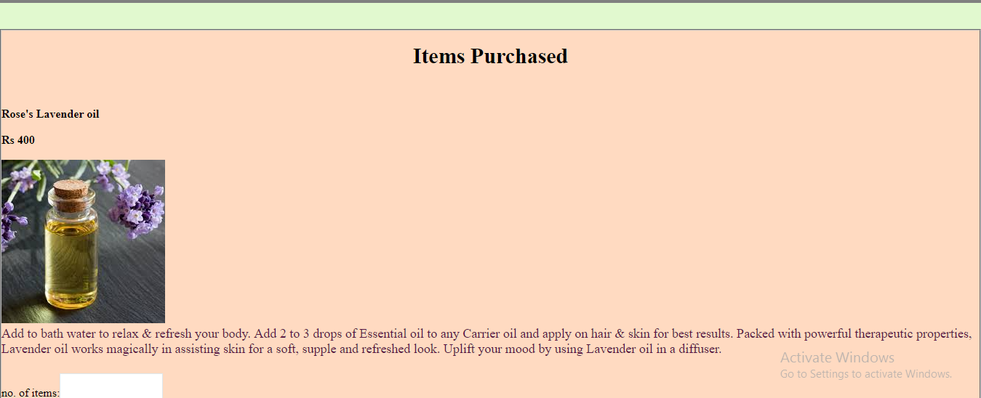
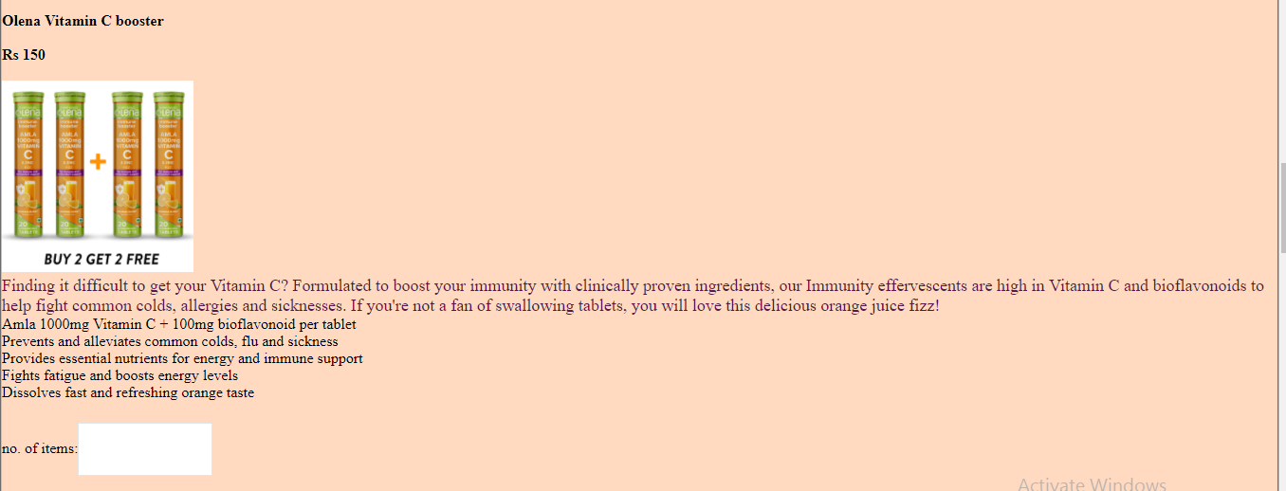
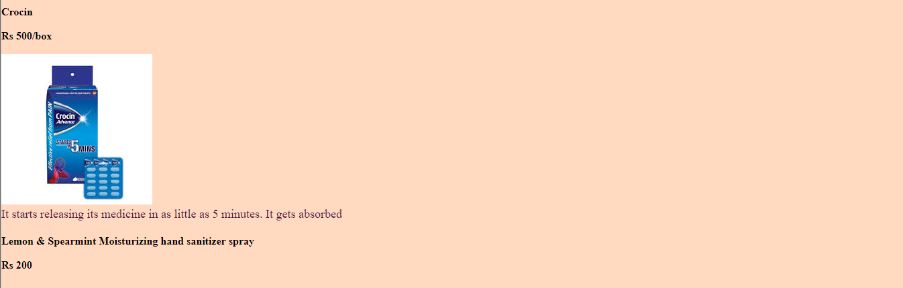
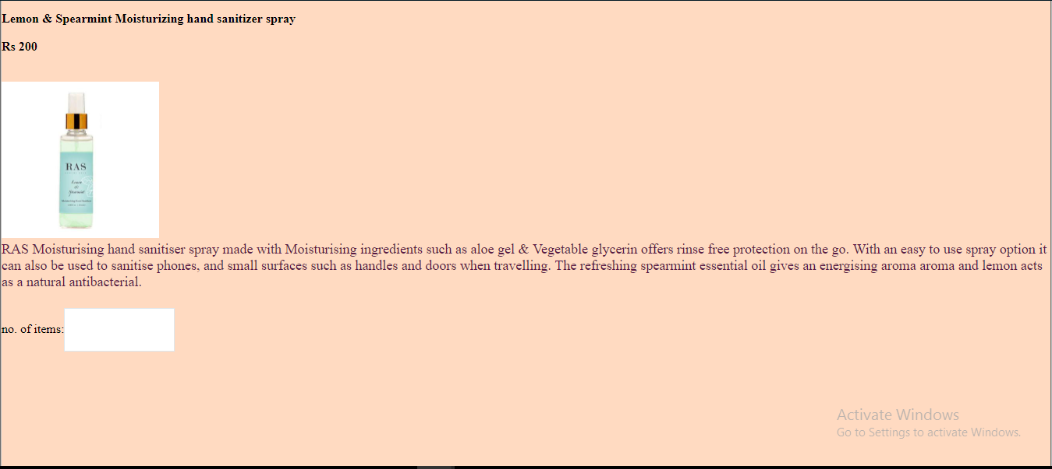

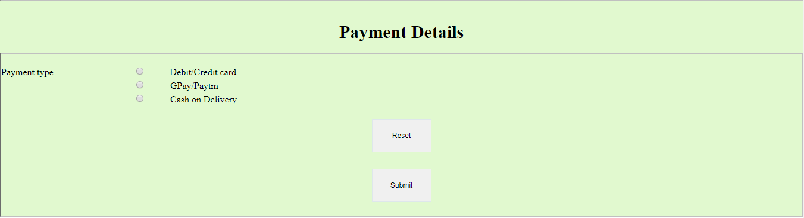

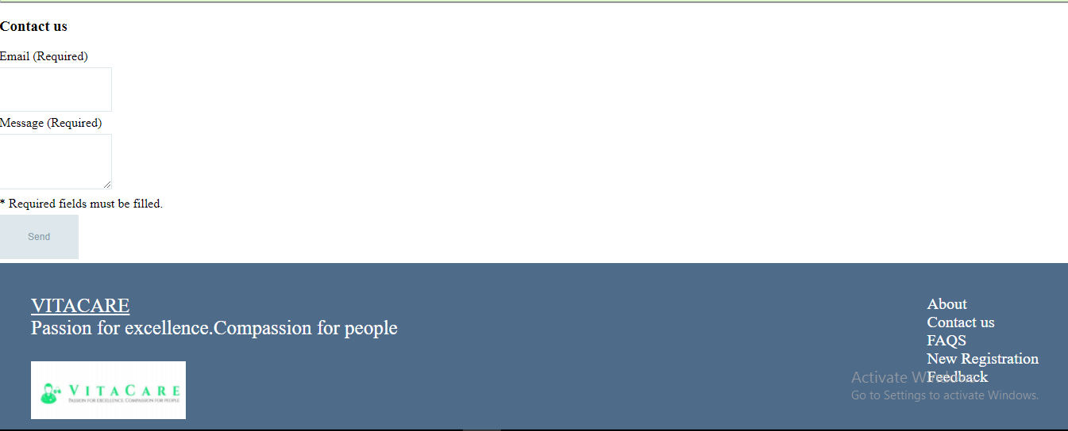
CONCLUSION: Hence the program was successfully compiled and executed.

